Laboratory Activity Part A: Pattern Identification & Justification
Pattern | Application in Project | Justification
Singleton | DatabaseConnection class in database.py. | Prevents opening multiple redundant connections to the SQLite file, reducing overhead and potential locking issues.
Repository | CourseRepository and StudentRepository. | Decouples the models from the SQL queries. If you ever switch from SQLite to MySQL, you only change the Repository, not the rest of the app.
Factory | RepositoryFactory. | Simplifies object creation. The Service layer doesn't need to know "how" to build a repository; it just asks the Factory for one.

PART B - IMPLEMENTATION

1. Singleton Pattern: Database Connection
Purpose: Ensures only one instance of the database connection manager exists to save resources.
Refactored config/database.py
Python
import sqlite3

class DatabaseConnection:
_instance = None

def __new__(cls):
if cls._instance is None:
cls._instance = super(DatabaseConnection, cls).__new__(cls)
cls._instance._conn = sqlite3.connect('online_courses.db', check_same_thread=False)
cls._instance._conn.row_factory = sqlite3.Row
return cls._instance

def get_connection(self):
return self._instance._conn

def init_db():
db = DatabaseConnection()
conn = db.get_connection()
cursor = conn.cursor()
cursor.execute('''CREATE TABLE IF NOT EXISTS courses (id INTEGER PRIMARY KEY AUTOINCREMENT, name TEXT NOT NULL, description TEXT)''')
cursor.execute('''CREATE TABLE IF NOT EXISTS students (id INTEGER PRIMARY KEY AUTOINCREMENT, name TEXT NOT NULL, email TEXT UNIQUE NOT NULL)''')
conn.commit()

init_db()
plantUml DIAGRAM :
@startuml
skinparam style strictuml
skinparam monochrome true

class DatabaseConnection <<Singleton>> {
- static _instance: DatabaseConnection
- _conn: sqlite3.Connection
--
+ __new__(): DatabaseConnection
+ get_connection(): Connection
}

note right of DatabaseConnection::__new__
If _instance is None:
Create new connection
Return _instance
end note

@enduml

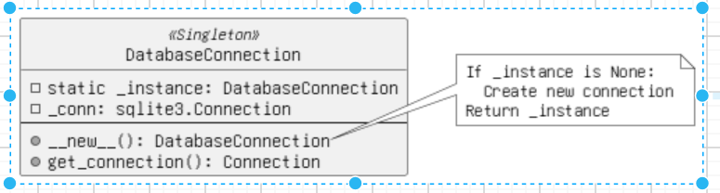

2. Repository Pattern: Data Access
Purpose: Separates the business logic from the data access logic. We move the SQL queries out of the Models and into dedicated Repository classes.
New repositories/courseRepository.py
Python
from config.database import DatabaseConnection
from models.courseModel import Course

class CourseRepository:
def __init__(self):
self.db = DatabaseConnection().get_connection()

def get_all(self):
cursor = self.db.cursor()
cursor.execute("SELECT * FROM courses")
return [Course(row['id'], row['name'], row['description']) for row in cursor.fetchall()]

def get_by_id(self, course_id):
cursor = self.db.cursor()
cursor.execute("SELECT * FROM courses WHERE id=?", (course_id,))
row = cursor.fetchone()
return Course(row['id'], row['name'], row['description']) if row else None
plantUml DIAGRAM :
@startuml
skinparam style strictuml
skinparam monochrome true

package "Models" {
class Course {
+ id: int
+ name: string
}
}

package "Repositories" {
class CourseRepository {
- db: Connection
+ get_all(): List<Course>
+ get_by_id(id: int): Course
}
}

class DatabaseConnection <<Singleton>>

CourseRepository --> DatabaseConnection : gets connection
CourseRepository ..> Course : creates/returns
@enduml
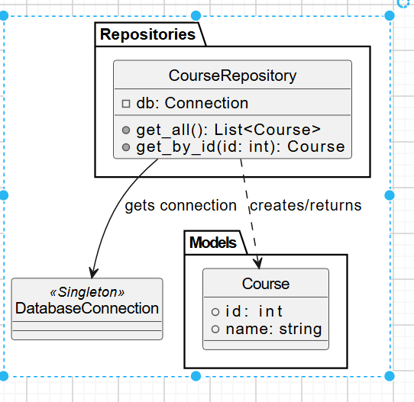

3. Factory Pattern: Object Creation
Purpose: Handles the instantiation of repositories or models, providing a centralized way to create objects without specifying the exact class.
New factories/repoFactory.py
Python
from repositories.courseRepository import CourseRepository
# Assume a similar StudentRepository exists
from repositories.studentRepository import StudentRepository

class RepositoryFactory:
@staticmethod
def get_repository(repo_type):
if repo_type == 'course':
return CourseRepository()
elif repo_type == 'student':
return StudentRepository()
return None

Refactored Service Layer
The Services now use the Factory to get a Repository, which uses the Singleton database connection.
Refactored services/courseService.py
Python
from factories.repoFactory import RepositoryFactory

# Use the factory to get the repository
course_repo = RepositoryFactory.get_repository('course')

def get_all_courses():
return course_repo.get_all()

def get_course(course_id):
return course_repo.get_by_id(course_id)
plantUml DIAGRAM:
@startuml
skinparam style strictuml
skinparam monochrome true

interface Repository

class CourseRepository implements Repository
class StudentRepository implements Repository

class RepositoryFactory <<Factory>> {
+ static get_repository(repo_type: string): Repository
}

class CourseService

CourseService --> RepositoryFactory : asks for 'course'
RepositoryFactory ..> CourseRepository : instantiates
@enduml
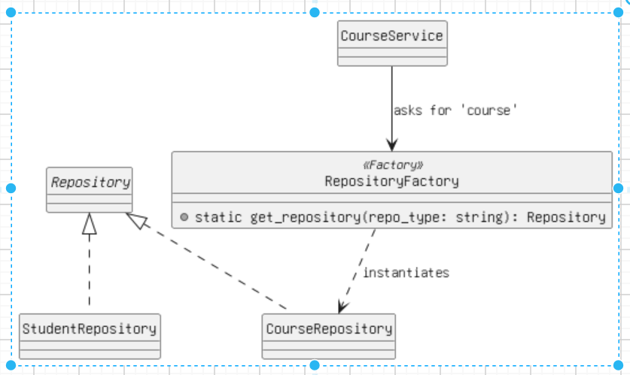

Laboratory Activity Part C: Documentation (UML Description)
To complete your draw.io task:
- Singleton: Draw a class DatabaseConnection with a private static attribute _instance and a public get_connection() method.
- Repository: Draw an Interface/Class CourseRepository with methods like get_all(). Show it interacting with the DatabaseConnection.
- Factory: Draw a RepositoryFactory class with a method get_repository(type). Draw arrows showing it "creates" the Repository classes.

Short design explanation document :
1. Structural Overview: MVC
The application is divided into three main layers to separate concerns:
- Models: Define the data structure (Course and Student).
- Views: HTML templates (Jinja2) for the user interface.
- Controllers: Handle user requests and coordinate between Services and Views.

2. Design Pattern Implementations
A. Singleton Pattern (Resource Management)
Location: config/database.py The Singleton pattern is applied to the database connection. By using the __new__ method, we ensure that only one instance of the connection exists throughout the application’s lifecycle.
- Benefit: Prevents multiple connections from slowing down the system and avoids "Database is locked" errors in SQLite.
B. Repository Pattern (Data Abstraction)
Location: repositories/ folder We decoupled the data access logic from the Models. The Repositories contain all the raw SQL queries.
- Benefit: If the database type changes (e.g., from SQLite to PostgreSQL), only the Repository files need to be modified; the Models and Services remain untouched.
C. Factory Pattern (Object Creation)
Location: factories/repoFactory.py The Factory pattern provides a centralized interface for creating objects. Instead of the Service layer manually importing and instantiating different repositories, it calls RepositoryFactory.get_repository('type').
- Benefit: Simplifies the Service layer and makes it easier to add new entities (like "Instructors" or "Grades") in the future.

3. System Flow
- Request: User accesses /courses.
- Controller: courseController receives the request.
- Service: Calls courseService, which asks the Factory for a Repository.
- Repository: Uses the Singleton connection to fetch data and maps it to a Model.
- Response: The Controller sends the data to the View for rendering.

